6A^{th} Grade: Unit 14, Lesson 4

- How many zero pairs are represented with the Algebra Tiles shown?
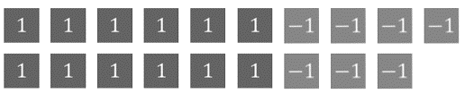

7

- What is the value of the set of Algebra Tiles provided?
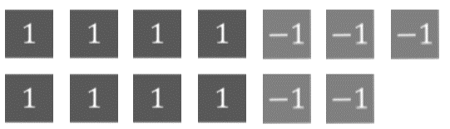

3

- Write the addition equation that can be represented by the bar model shown.
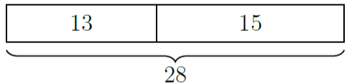

13 + 15 = 28

